4018 Determination of Breaking Force for Glass Ampoules
The breaking force is the force to be applied to separate the stem of the ampoule from the body.
Instrument: Ampoule breaking force tester. A material testing machine or other device whose function meets the requirements of this test can be used. The indication error of the instrument shall be within ±1% of the actual value.
The Instrument is shown in the figure.
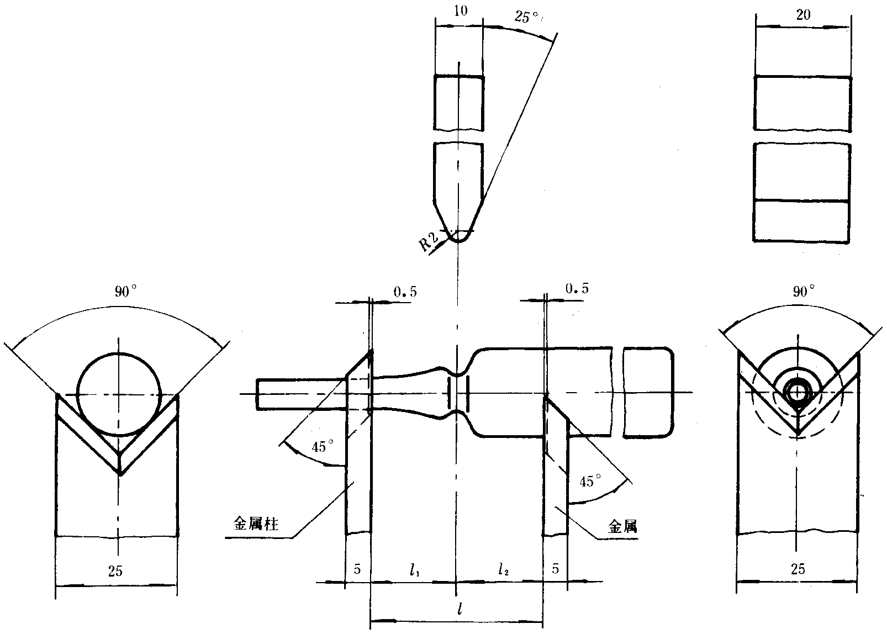
Metal support
Metal support
Figure Set-up for determining the breaking force of glass ampoules
Determination: Test speed (no load): 10 mm/min±0.5 mm/min; Measuring range: 0-200 N, precision: 0.1 N. The distances between the metal bars are given in the table below.
Table Ampoule size and distance between metal bars
Size (ml) | Distance between metal bars, l = (l₁ + l₂) (mm)
1 | 36=(18+18)
2
3
5
10 | 60=(22+38)
20
25
30

Place the sample in the middle of two metal bars with appropriate distance (as shown in the figure and according to the table). Apply force with the ampoule breaking force tester until the ampoule breaks and record the value of breaking force.
Note: When determining the breaking force of one-point-cut easy-to-break ampoules, the force applying component of the device shall be positioned in the middle of the cut (with the cut facing down), otherwise the breaking force will increase.

Drafted by: National Institutes for Food and Drug Control Contact number: 010-67095110

